Sample school newsletter copy:

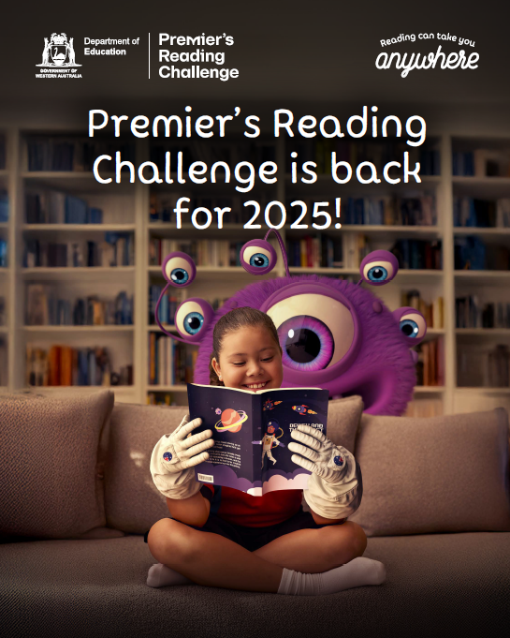

**Discover the magic of reading**

Register your child for the Premier's Reading Challenge! From 7 April to 27 June 2025, students from Kindergarten to Year 12 can discover the joy of reading and log their progress for a chance to win weekly prizes.

Visit premiersreadingchallenge.wa.edu.au for more information.